Figure S1. Odds ratios for poor sleep quality after excluding two Pittsburgh Sleep Quality Index items (‘feeling too cold’ and ‘feeling too hot’)
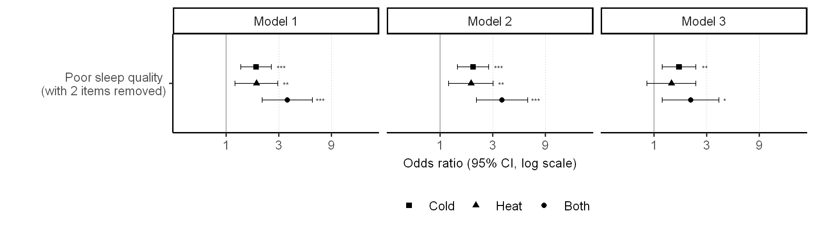
Poor sleep quality was assessed by Pittsburgh Sleep Quality Index with the exclusion of two questionnaire items (‘feel too cold’ (item no. 5f) and ‘feel too hot’ (item no. 5g)). The cut-off scores for Component 5 were adjusted to 0, 7, 14, and 21. CI, confidence interval; *, P < 0.05; **, P < 0.01; ***, P < 0.001; Model 1: adjusted for age, body mass index; Model 2: adjusted for variables in Model 2, smoking, alcohol consumption, physical activity, education, household income, marital status, and menopause; Model 3: adjusted for variables in Model 2, EuroQol-visual analogue scales, Beck Depression Inventory score, and use of sleeping medication; Reference group: no-sensation group.

